WEEK 5

SESSION 1: Maximum Subarray (Brute → Optimized)

TASK 1 : Maximum Sub Array

Program :
class Solution {
public static int maxSubArray(int[] nums) {
int res = nums[0];
int maxEnding = nums[0];

for (int i = 1; i < nums.length; i++) {
maxEnding = Math.max(maxEnding + nums[i], nums[i]);
res = Math.max(res, maxEnding);
}

return res;
}

public static void main(String[] args) {
int[] nums = {-2,1,-3,4,-1,2,1,-5,4};
System.out.println(maxSubArray(nums));
}
}

Output:
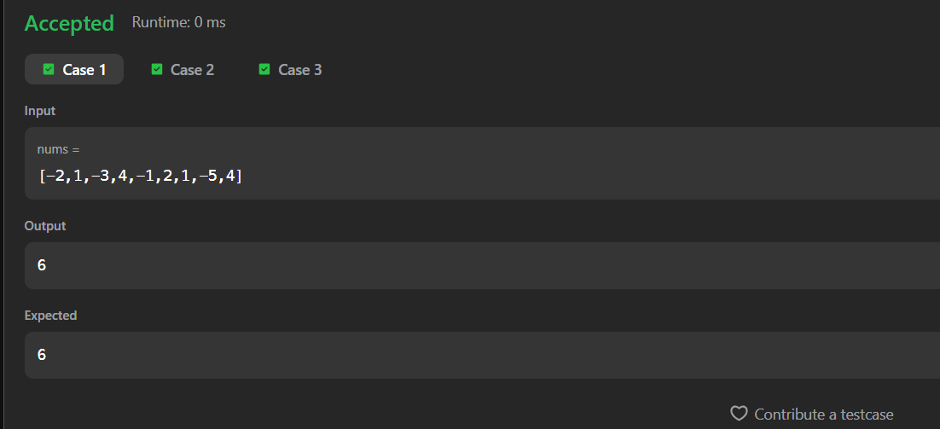

TASK 2: The Birthday Bar

Program
import java.util.*;

class Result {

public static int birthday(List<Integer> s, int d, int m) {

int count = 0;

for (int i = 0; i <= s.size() - m; i++) {

int sum = 0;

for (int j = i; j < i + m; j++) {
sum += s.get(j);
}

if (sum == d) {
count++;
}
}

return count;
}
}

public class Solution {

public static void main(String[] args) {

Scanner sc = new Scanner(System.in);

int n = sc.nextInt();

List<Integer> s = new ArrayList<>();

for (int i = 0; i < n; i++) {
s.add(sc.nextInt());
}

int d = sc.nextInt();
int m = sc.nextInt();

System.out.println(Result.birthday(s, d, m));

sc.close();
}
}

Output:
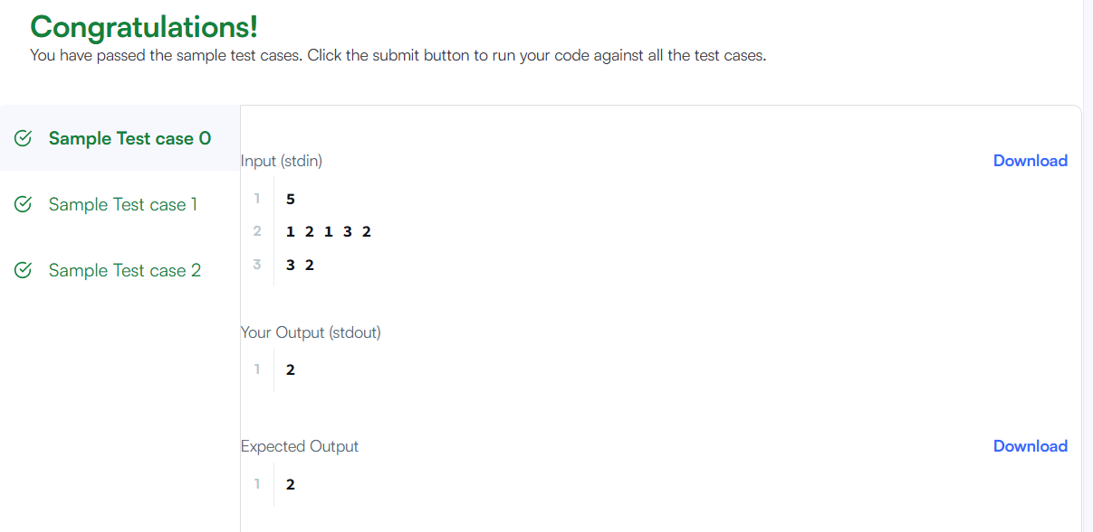

SESSION 2: Kadane’s Algorithm

TASK 3: Maximum Subarray

Program :
import java.io.*;
import java.util.*;

class Result {

public static List<Integer> maxSubarray(List<Integer> arr) {

int current = arr.get(0);
int maxSubarray = arr.get(0);

int maxSubsequence = arr.get(0);

for (int i = 1; i < arr.size(); i++) {

int x = arr.get(i);

// Maximum subarray
current = Math.max(x, current + x);
maxSubarray = Math.max(maxSubarray, current);

// Maximum subsequence
if (x > 0) {
maxSubsequence += x;
}
}

// If all numbers are negative
if (maxSubsequence < 0) {
maxSubsequence = Collections.max(arr);
}

return Arrays.asList(maxSubarray, maxSubsequence);
}
}

public class Solution {

public static void main(String[] args) throws IOException {

BufferedReader br = new BufferedReader(new InputStreamReader(System.in));

int t = Integer.parseInt(br.readLine().trim());

while (t-- > 0) {

int n = Integer.parseInt(br.readLine().trim());

StringTokenizer st = new StringTokenizer(br.readLine());

List<Integer> arr = new ArrayList<>();

while (st.hasMoreTokens()) {
arr.add(Integer.parseInt(st.nextToken()));
}

List<Integer> result = Result.maxSubarray(arr);

System.out.println(result.get(0) + " " + result.get(1));
}
}
}

Output:
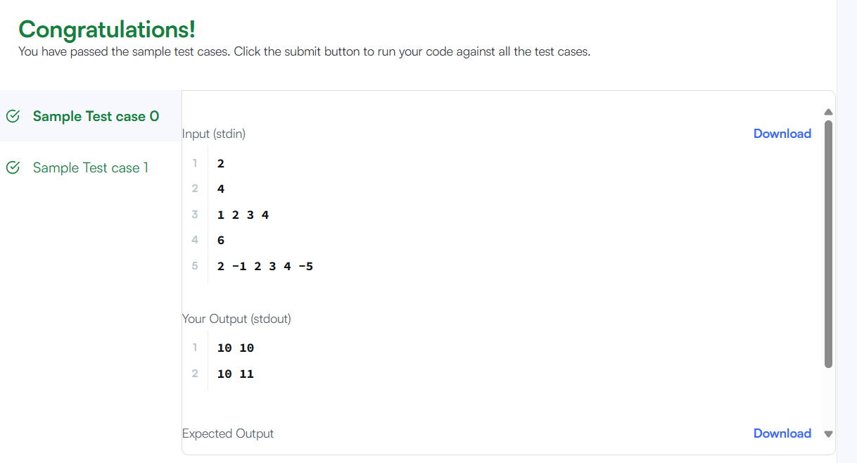

TASK 4: Maximum Sum Circular Subarray

Program:
class Solution {
public int maxSubarraySumCircular(int[] nums) {

int totalSum = 0;

int maxEnding = nums[0];
int maxSum = nums[0];

int minEnding = nums[0];
int minSum = nums[0];

for (int i = 0; i < nums.length; i++) {

totalSum += nums[i];

if (i > 0) {
maxEnding = Math.max(maxEnding + nums[i], nums[i]);
maxSum = Math.max(maxSum, maxEnding);

minEnding = Math.min(minEnding + nums[i], nums[i]);
minSum = Math.min(minSum, minEnding);
}
}

// All elements are negative
if (maxSum < 0) {
return maxSum;
}

// Maximum of normal and circular subarray
return Math.max(maxSum, totalSum - minSum);
}
}

Output :
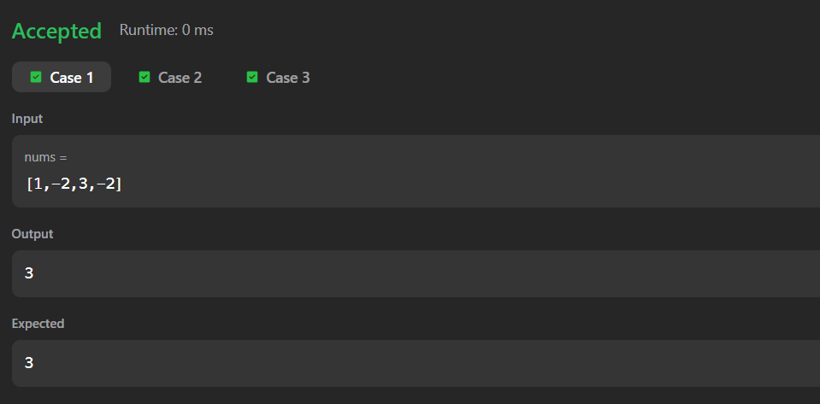

TASK 5: String to Integer (atoi)

Program :
class Solution {
public int myAtoi(String s) {

int i = 0;
int n = s.length();

// 1. Skip leading spaces
while (i < n && s.charAt(i) == ' ') {
i++;
}

// 2. Check sign
int sign = 1;

if (i < n && s.charAt(i) == '-') {
sign = -1;
i++;
} else if (i < n && s.charAt(i) == '+') {
i++;
}

// 3. Convert digits
int result = 0;

while (i < n && Character.isDigit(s.charAt(i))) {

int digit = s.charAt(i) - '0';

// 4. Check overflow before multiplying
if (result > (Integer.MAX_VALUE - digit) / 10) {
if (sign == 1) {
return Integer.MAX_VALUE;
} else {
return Integer.MIN_VALUE;
}
}

result = result * 10 + digit;
i++;
}

return result * sign;
}
}

Output:
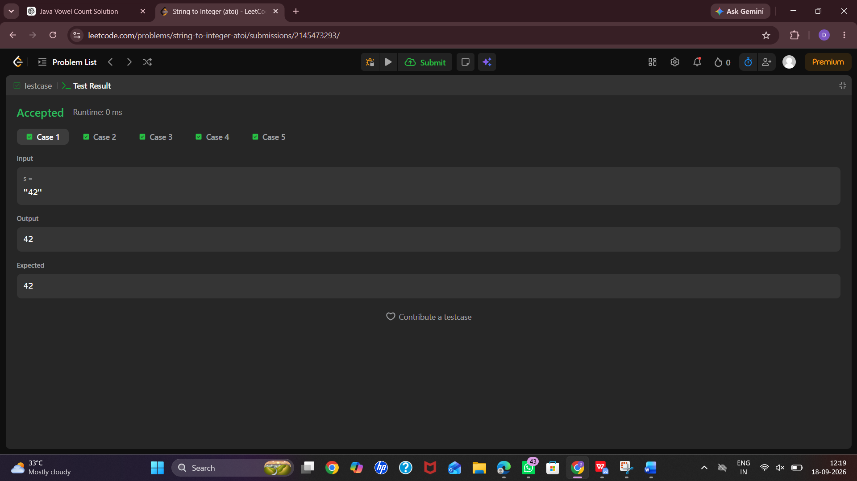

TASK 6 : Alternating Characters

Program :
import java.util.*;

class Result {

public static int alternatingCharacters(String s) {

int deletions = 0;

for (int i = 1; i < s.length(); i++) {

if (s.charAt(i) == s.charAt(i - 1)) {
deletions++;
}
}

return deletions;
}
}

public class Solution {

public static void main(String[] args) {

Scanner sc = new Scanner(System.in);

int q = sc.nextInt();

while (q-- > 0) {

String s = sc.next();

System.out.println(Result.alternatingCharacters(s));
}

sc.close();
}
}

Output:
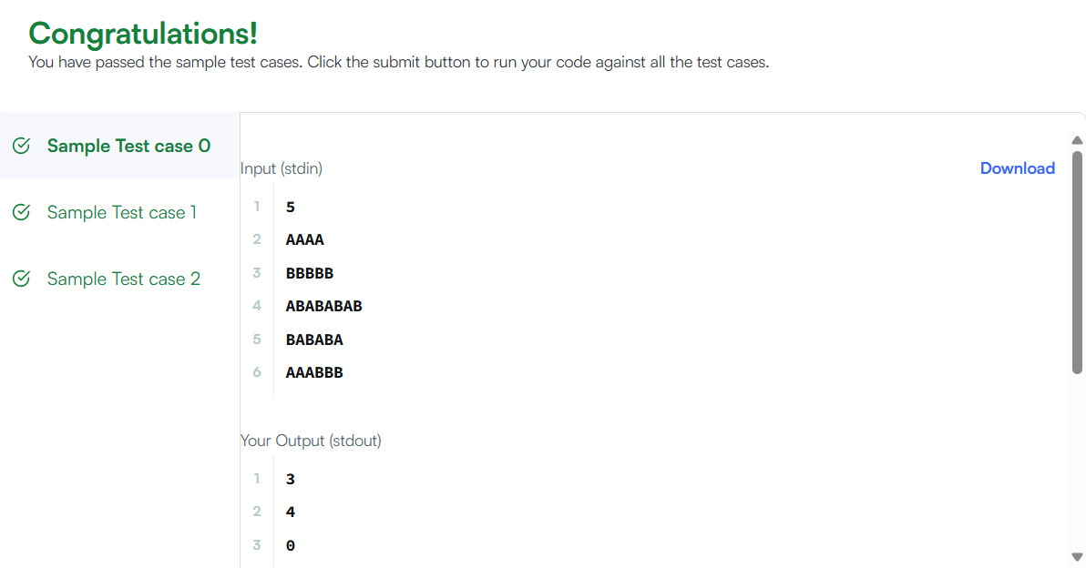

SESSION 4: Advanced String Techniques

TASK 7 : Longest Substring without repeating characters

Program :
import java.util.*;

class Solution {
public int lengthOfLongestSubstring(String s) {
HashSet<Character> set = new HashSet<>();

int left = 0;
int maxLength = 0;

for (int right = 0; right < s.length(); right++) {

while (set.contains(s.charAt(right))) {
set.remove(s.charAt(left));
left++;
}

set.add(s.charAt(right));

maxLength = Math.max(maxLength, right - left + 1);
}

return maxLength;
}
}

Output :
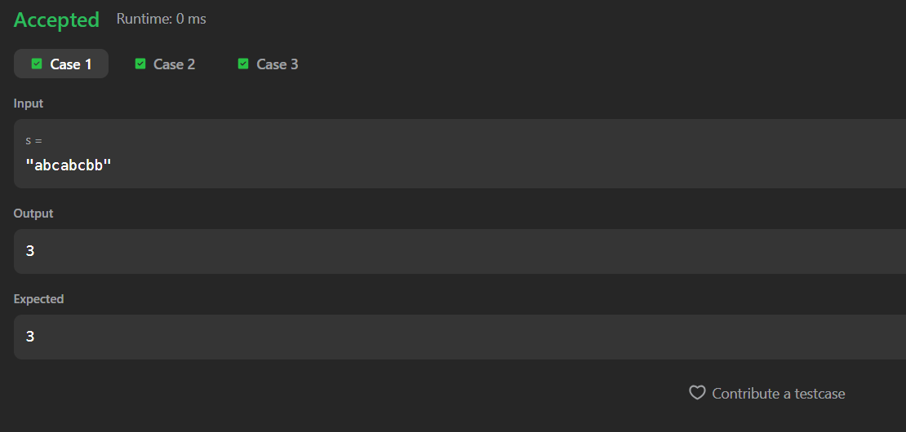

TASK 8: Find and Replace Pattern

Program:
import java.util.*;

class Solution {
public List<String> findAndReplacePattern(String[] words, String pattern) {
List<String> result = new ArrayList<>();

for (String word : words) {
if (matches(word, pattern)) {
result.add(word);
}
}

return result;
}

private boolean matches(String word, String pattern) {
Map<Character, Character> map = new HashMap<>();
Map<Character, Character> reverseMap = new HashMap<>();

for (int i = 0; i < pattern.length(); i++) {
char p = pattern.charAt(i);
char w = word.charAt(i);

if (map.containsKey(p) && map.get(p) != w) {
return false;
}

if (reverseMap.containsKey(w) && reverseMap.get(w) != p) {
return false;
}

map.put(p, w);
reverseMap.put(w, p);
}

return true;
}
}

Output :
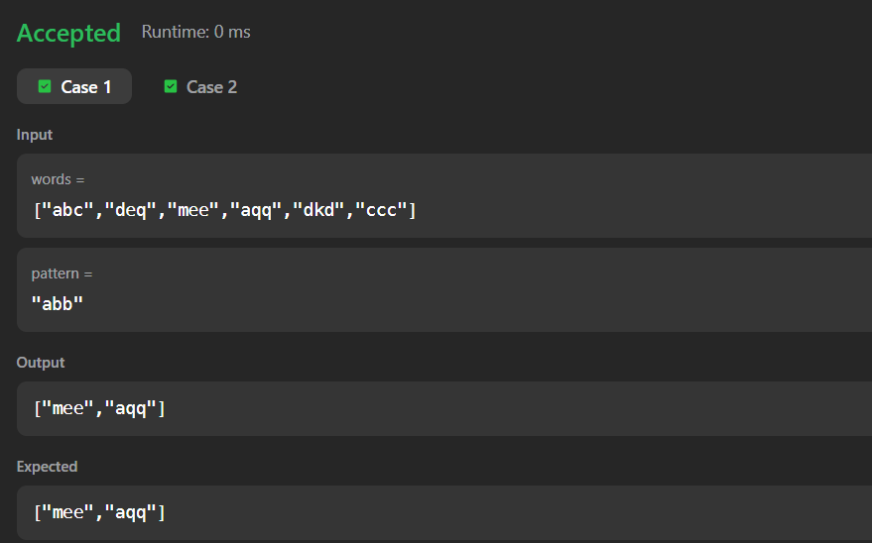

SESSION 5: Naive Pattern Matching

TASK 9 : String matching in an array

Program:
import java.util.*;

class Solution {
public List<String> stringMatching(String[] words) {
List<String> result = new ArrayList<>();

for (int i = 0; i < words.length; i++) {
for (int j = 0; j < words.length; j++) {

if (i != j && words[j].contains(words[i])) {
result.add(words[i]);
break;
}
}
}

return result;
}
}

Output :
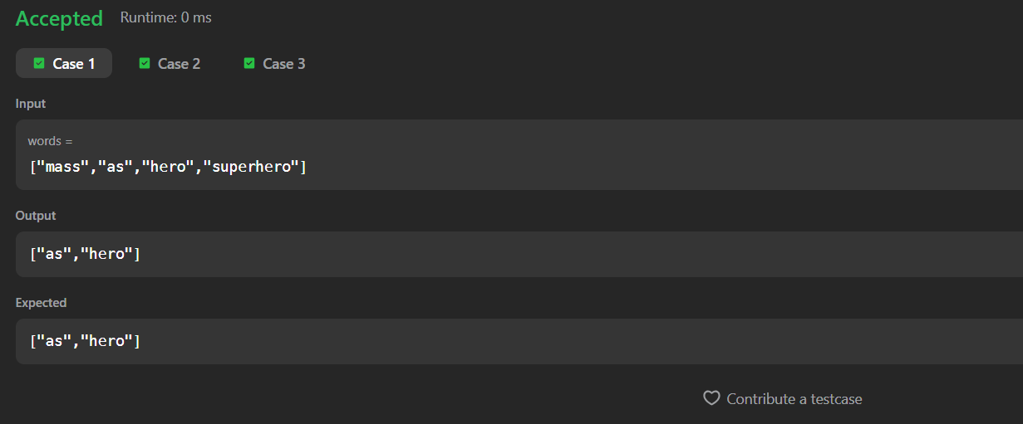

TASK 10: Naive algorithm for Pattern Searching

Program :
import java.util.*;

public class GFG {

public static ArrayList<Integer> search(String pattern, String text) {
ArrayList<Integer> result = new ArrayList<>();

int n = text.length();
int m = pattern.length();

for (int i = 0; i <= n - m; i++) {
int j = 0;

while (j < m && text.charAt(i + j) == pattern.charAt(j)) {
j++;
}

if (j == m) {
result.add(i);
}
}

return result;
}

public static void main(String[] args) {
String text = "geeksforgeeks";
String pattern = "geeks";

ArrayList<Integer> result = search(pattern, text);

System.out.println(result);
}
}

Output:
